

# AMERICAN INTERNATIONAL UNIVERSITY – BANGLADESH (AIUB)

**FACULTY OF SCIENCE & TECHNOLOGY DEPARTMENT OF COMPUTER SCIENCE COMPUTER GRAPHICS**

**Spring 2023-2024**

# Section: D, Group: 05

Project Title: Futuristic City View & Smart Fire Management System

Supervised By

**ANEEM AL AHSAN RUPAI**

# Individual Report By: A. F. M. RAFIUL HASSAN

# ID: 22-47048-1

# Group Member:

|  |  |
| --- | --- |
| **Name** | **ID** |
| FARJANA YESMIN OPI | 22-47018-1 |
| MD. ABU TOWSIF | 22-47019-1 |
| A.F.M. RAFIUL HASSAN | 22-47048-1 |

**Table of Contents**

|  |  |
| --- | --- |
| **Topic** | **Page No.** |
| Introduction | 3-4 |
| Project Graph(s) | 5 |
| List of Objects | 6 |
| List of Functions | 7 |
| List of Animation Functions | 8 |
| Contribution | 8 |
| Conclusion | 9 |
| Output Image | 10-12 |

# Introduction

The title of our project is "Futuristic City View & Smart Fire Management System." Here, we aim to showcase a vision of what a futuristic city might look like and how fire emergencies could be handled in the future.

**Scenario 1: A City of the Future:**

This scenario depicts a city equipped with the next generation of urban infrastructure. It features futuristic bullet trains, sleek cars, and towering buildings with integrated underground train stations. Additionally, both advanced and self-driving cars are present, alongside robots playing a prominent role in everyday life. Animations are included to enhance the realism of these objects.

**Scenario 2: The Next-Gen Fire Station:**

This scenario focuses on a futuristic fire station, showcasing its advanced design. It houses vehicles such as fire trucks and helicopters, both controllable by the user through keyboard functions. The main theme revolves around a building fire. Upon activation, the fire truck and helicopter are sent to extinguish the flames with a rain effect, complemented by a zooming feature for closer inspection.

**Scenario 3: A Modern Metropolis:**

This scenario portrays another futuristic city, with a distinct design compared to the first one. It features smart cars, a modern bullet train, and contemporary buildings. Flying cars take to the skies alongside the controllable bullet train. Animations depict the movement of flying cars and even the gentle sway of flowers and leaves. Realistic sound effects further immerse the viewer, including train whistles, bird chirps, and helicopter rotors. Birds soar across the sky, adding to the scene's vibrancy.

The core concept of this scenario involves a building fire. A helicopter from the fire station automatically deploys to extinguish the blaze with a rain effect. The helicopter's movement is directly tied to the fire animation. Only when fire particles appear on screen will the helicopter arrive and commence firefighting. This scenario showcases a combination of fire effects, automated helicopter response, and a rain extinguishing method. Its purpose is to illustrate both a smart fire management system and a modern, futuristic city environment.

**Overall Project Objective:**

The project's main objective is to create a visualization of a futuristic city and demonstrate how fire management systems could evolve in the near future.

**Technologies Used:**

# Our project was entirely created using OpenGL. We’ve used various OpenGL features such as line, polygon, and circle drawing, as well as moving and rotation animations. To visualize the project, we utilized the online graphing tool GeoGebra. Also, we used vectors and designs sourced from online resources like Freepik and Shutterstock. The project also includes BMP images and textures.

# Project Graph

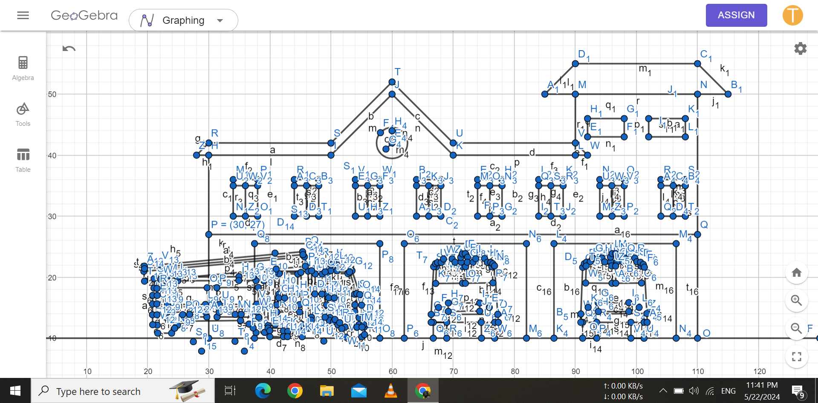

# List of Objects (Fire Station)

|  |  |  |
| --- | --- | --- |
| SL# | Object ID | Object Name |
| 1 | ID – 01 | building_firestation |
| 2 | ID – 02 | sky |
| 3 | ID – 03 | road |
| 4 | ID – 04 | green_area |
| 5 | ID – 05 | helicopter |
| 6 | ID – 06 | truck_01 |
| 7 | ID – 07 | truck_02 |
| 8 | ID – 08 | truck_03 |
| 9 | ID – 09 | tree_back |
| 10 | ID – 10 | watch_time |
| 11 | ID – 11 | sun |
| 12 | ID – 12 | tree01 |
| 13 | ID – 13 | tree02 |
| 14 | ID – 14 | tree03 |
| 15 | ID – 15 | tree04 |
| 16 | ID – 16 | tree05 |
| 17 | ID – 17 | text |
| 18 | ID – 18 | wheel_01 |
| 19 | ID – 19 | wheel_02 |
| 20 | ID – 20 | wheel_03 |

**List of Functions (Fire Station)**

|  |  |  |
| --- | --- | --- |
| SL# | Object Name | FunctionName |
| 1 | building_firestation | building_firestation() |
| 2 | sky | sky() |
| 3 | road | road() |
| 4 | green_area | green_area() |
| 5 | helicopter | helicopter() |
| 6 | truck_01 | truck_01() |
| 7 | truck_02 | truck_02() |
| 8 | truck_03 | truck_03() |
| 9 | tree_back | tree_back() |
| 10 | watch_time | watch_time() |
| 11 | sun | sun() |
| 12 | tree01 | tree01() |
| 13 | tree02 | tree02() |
| 14 | tree03 | tree03() |
| 15 | tree04 | tree04() |
| 16 | tree05 | tree05() |
| 17 | text | text() |
| 18 | wheel_01 | wheel_01() |
| 19 | wheel_02 | wheel_02() |
| 20 | wheel_03 | wheel_03() |

**List of Animation Functions (Fire Station)**

|  |  |  |  |
| --- | --- | --- | --- |
| SL# | Animation Function ID | Animation Function | Object/Scene |
| 1 | ID – 21 | move_function |  |
| 2 | ID – 22 | zoom_to_scenario_03_function | Zoom to helicopter |
| 3 | ID – 23 | rotate_fan1 | helicopter, wheels |
| 4 | ID – 24 | move_helicopter | helicopter |
| 5 | ID – 25 | movetruck | truck |
| 6 | ID – 26 | kepress_handle | keyboard press interaction |
| 7 | ID – 27 | zoom_to_normal_view | zoom to normal view |
| 8 | ID - 28 | keyborard_func | keyboard press interaction |

**Contribution:**

|  |  |  |
| --- | --- | --- |
| **Implemented Functions** | **Implemented Animation Functions** | **Percentage of Contribution** |
| 20 | 8 | 100% |

# 

# Conclusion

In conclusion, our project "Futuristic City View & Smart Fire Management System" successfully illustrates a visionary outlook on urban development and emergency response systems. The first scenario provides a glimpse into the daily life of a futuristic city, highlighting innovations such as bullet trains, smart cars, and the widespread use of robots. The second scenario showcases the evolution of fire stations, equipped with state-of-the-art vehicles and preparedness to tackle emergencies efficiently. Scenario three provides a vivid representation of a modern futuristic city, emphasizing advanced technologies and their integration into urban life. The highlight of scenario three is the smart fire management system, which showcases the efficiency and responsiveness of future emergency services. The dynamic interaction between fire particles and the automated helicopter illustrates a sophisticated and adaptive approach to firefighting. The helicopter's rain effect to extinguish the fire not only demonstrates advanced technology but also emphasizes the importance of quick and effective emergency response in future cities. Utilizing OpenGL for creating animations and designs, along with tools like Geogebra for graphing, we have ensured a high level of detail and interactivity in our project. The use of BMP pictures and textures along with wav files for sound effect has further enhanced the visual appeal and realism of third scenario in fact the whole project.

Overall, this project not only serves as a conceptual model for futuristic city planning and fire management but also highlights the potential of current technology to shape the cities of tomorrow. We hope this project inspires further exploration and development in urban innovation and emergency response systems.

# Output Screenshots

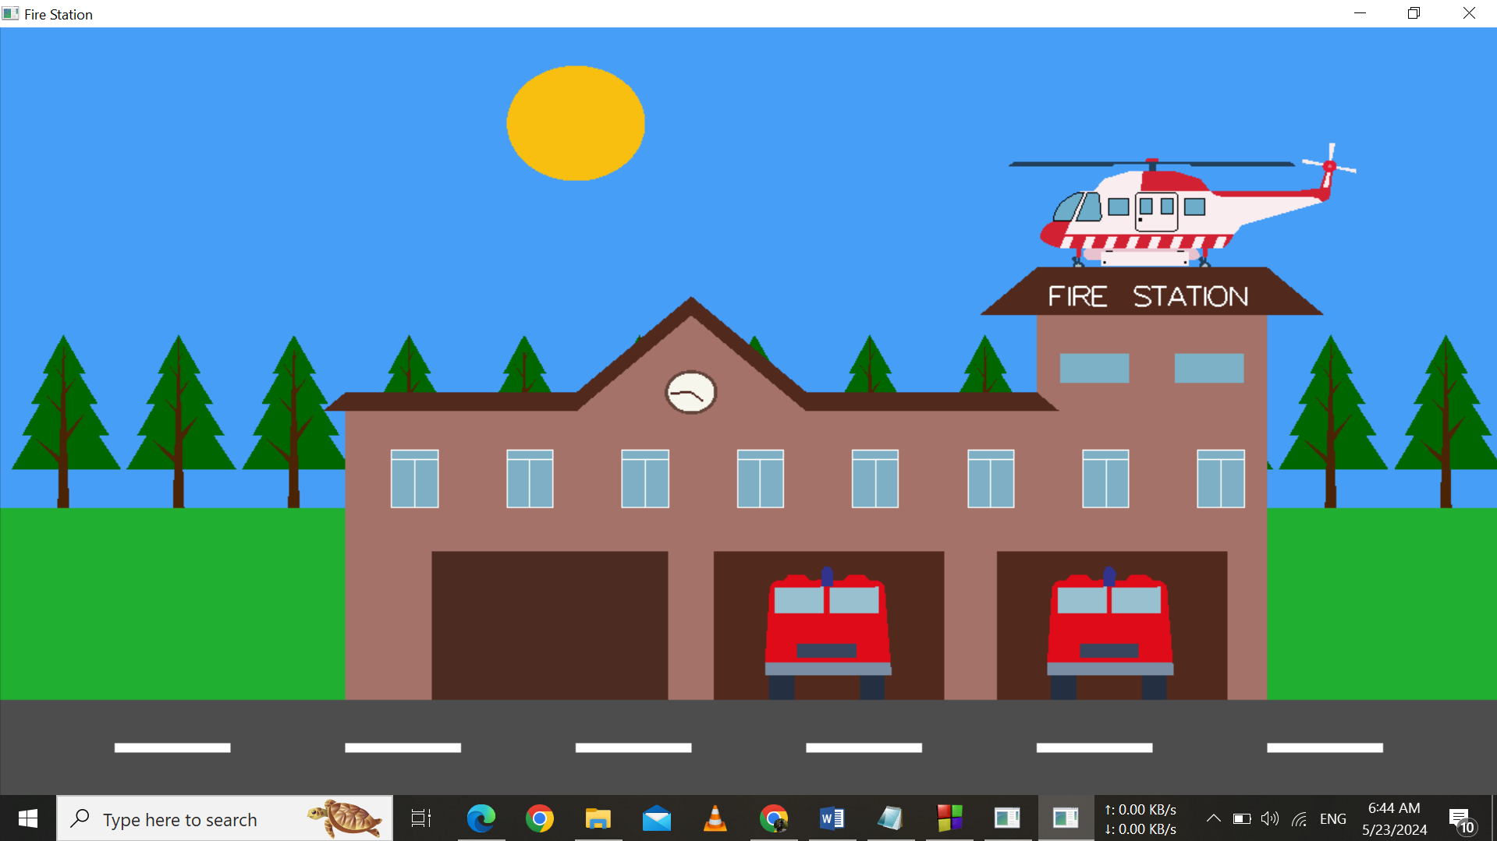

Screenshot – 01: The Initial View of Fire Station

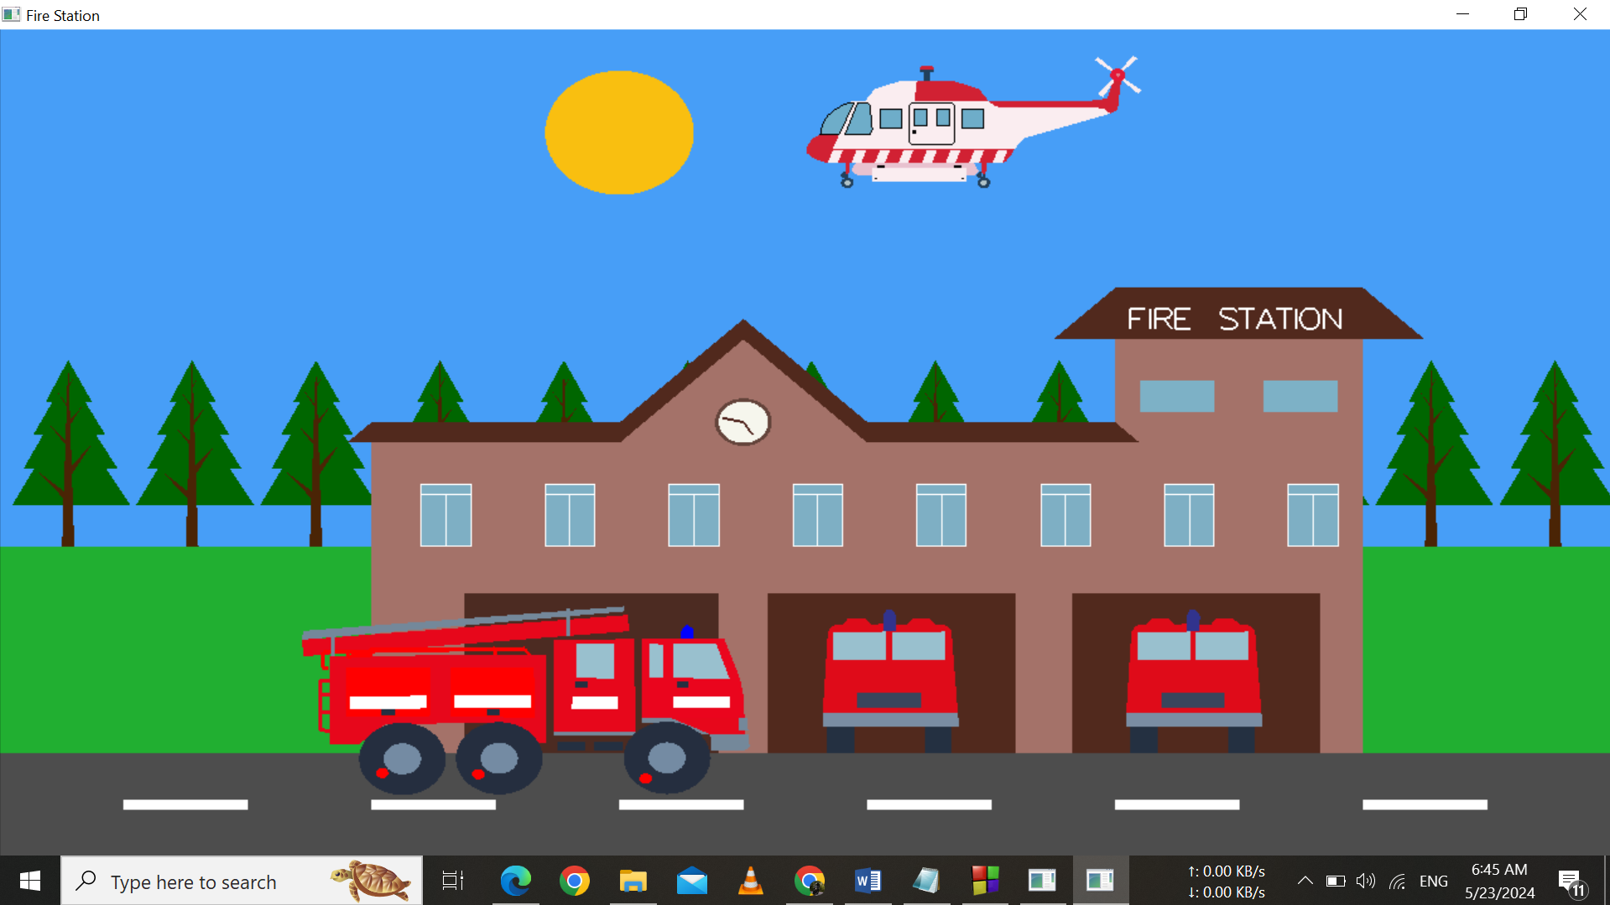

Screenshot – 02: When the helicopter is moving to distinguish the fire

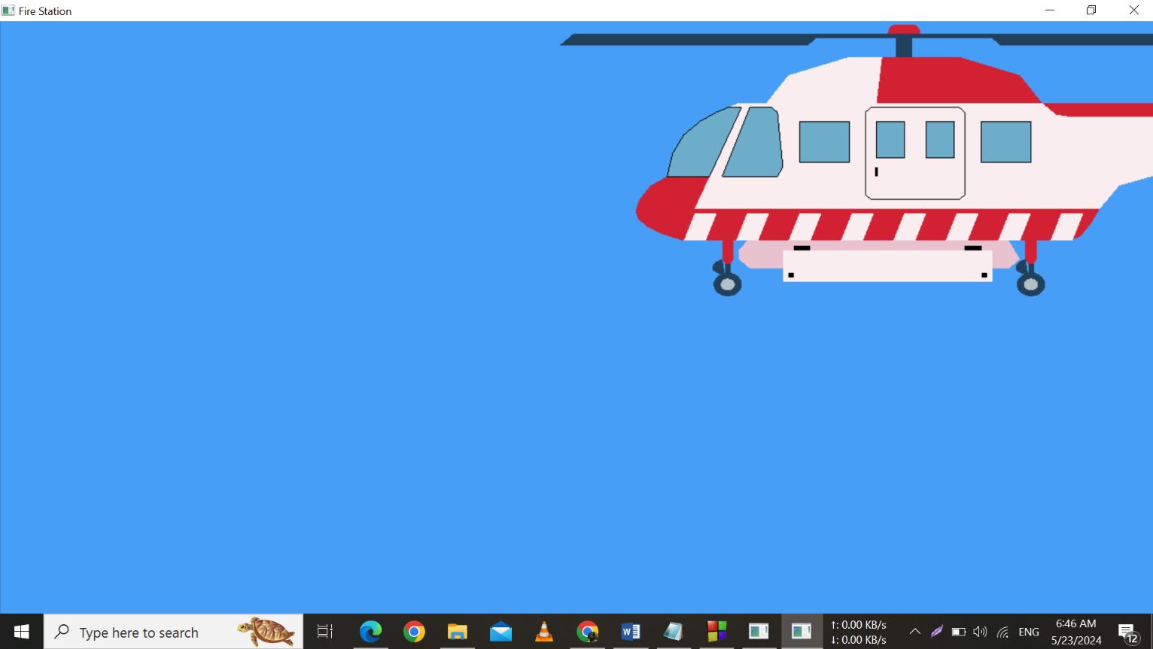

Screenshot – 03: The zooming effect on the helicopter

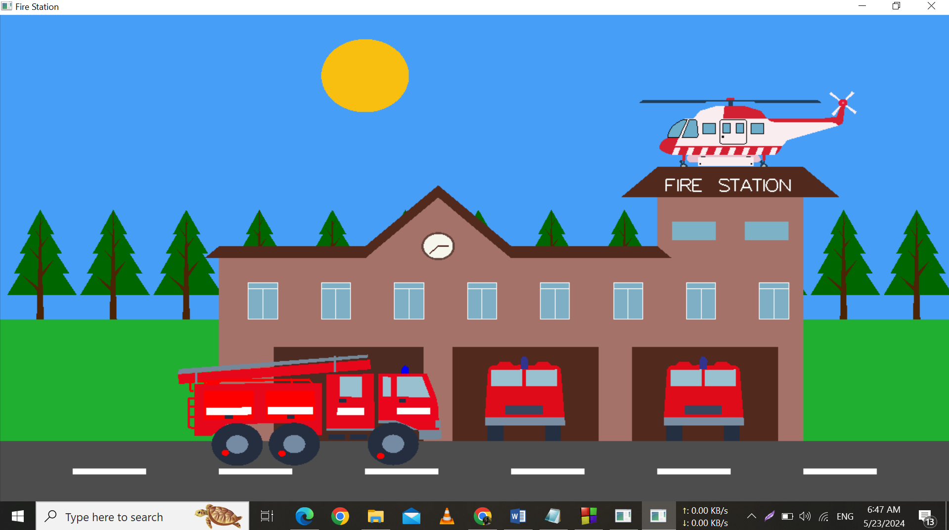

Screenshot – 04: The Last View of The Fire Station